|  |
| --- |
| BLUEsat UNSW Student Satellite Project  Document BLUE.2011.3.0 |
| Batteries & Solar Panels |
| Progress Report |
| **Authors and Contributors:**  Thomas Fisk  **Date:** |
| August 13th, 2012 |

# Introduction

trololo

# Table of Contents

1 Introduction 1

2 Table of Contents 1

3 New Specifications 2

4 Current Development Board 3

5 Future Work 4

6 Conclusion 5

# Specifications

## Power requirements of BLUEsat mission

The BLUEsat balloon launch mission is expected to last several days. In Alice Springs around March 2013, the day/night cycle will be approximately 12 hours of daylight and night-time[1]. Average power consumption could be up to 11.6 W (**see power budget document**) assuming the transmitter radios are permanently switched on at full power (this is an unlikely scenario, so the actual average power requirements will be much less.

In order to continually power BLUEsat throughout the entire duration of the mission, the following is therefore required:

1. The batteries must have sufficient capacity to power BLUEsat throughout the entire night period (i.e. to last over 12 hours).
2. The solar array must be able to generate enough power to power the satellite during the day, and to charge the batteries to full capacity in order to last the entire night period.

## Physical requirements of solar array

The BLUEsat solar array consists of either 5 or 6 solar panels, each mounted onto a side of the satellite structure as pictured in Figure 5.3.1. Each solar panel must fit onto a side of the BLUEsat structure, of dimensions (dimensions). The Z+ solar panel must accommodate the receiver antenna located at the centre of the panel.

## Physical requirements of batteries

The batteries are to be mounted securely in Tray 3, which has dimensions (dimensions). Mass is not considered a priority for the balloon launch mission, however it should not be excessively heavy.

# Batteries

## Battery Selection

BLUEsat will use a single string of 14 C-sized Nickel Metal Hydride (NiMH) battery cells, totalling a nominal supply voltage of 16.8V (1.2V per cell). This is a convenient voltage for the switch-mode regulators to step down to the required voltages for operation of the satellite’s different loads.

## Battery Packs

## Mounting

# Solar Array

## Solar Cells

The previous design of the solar arrays (seen in Figure 5.3.1) used 14 Spectrolab gallium arsenide solar cells on each panel. Due to the prohibitively high cost of purchasing new Gallium Arsenide cells, the decision has been made to primarily use monocrystalline silicon solar cells for the balloon launch.

While BLUEsat does still have about 150 Spectrolab GaAs cells in stock that were purchased in 2004, it is believed that they have undergone some degradation due to moisture and other factors. Most of them are however still perfectly functional, and may be used on the balloon launch in conjunction with silicon cells (e.g. have one panel with GaAs cells, Si cells on all other cells).

There have been two complications with using mono-crystalline silicon solar cells on BLUEsat. These are:

1. A single mono-crystalline solar cell is typical 125 mm by 125 mm in size (or larger). This is too large for more than one to be placed on a single BLUEsat solar panel, each which has dimensions 240 mm by 240 mm.
2. The minimum voltage required for the battery charge regulator (BCR) to draw power from each solar panel is 2.7V. This requires a multiple cells (nominally ~0.6 V per cell) to be placed in series.

The solution to both of these problems has been to use 125 mm cells that have been cut into 5 pieces (125 mm by 25 mm, shown in Figure 5.2.1). 12 of these smaller cells are arranged in series to produce a nominal voltage of about 7V.

Low cost pre-cut sells from Xiamen Mars Rock have been used in the prototypes. Higher quality cells suck as the Deutsche Cell DCM125 cells may be used for the final launch. These cells have essentially the same dimension as the low cost cells used, however they need to be cut by a supplier in order for the cells to fit on the solar panels.

## Solar Panels

The BLUEsat solar array consists of either 5 or 6 solar panels, each mounted onto a side of the satellite structure as pictured in Figure 5.3.1. Originally, it was intended for the solar array to be mounted on all 6 sides of the Satellite, including the –Z (bottom/baseplate) side. Because the satellite will be oriented with the –Z side facing Earth during the balloon launch, it has been decided that a solar panel on the –Z side will be unnecessary.

Each solar panel consists of the solar cells mounted onto a printed circuit board (PCB), along with bypass diodes and a temperature sensor. Cells glued with a thermally conductive epoxy to the PCB and tabbing wire is soldered onto contacts on the PCB.

Currently, a prototype of a silicon solar panel has been constructed, pictured in Figure 5.2.1. This prototype has been constructed primarily for testing of the Battery Charge Regulator (BCR) subsystem. To reduce the cost of the prototype, a fibreglass (FR4) PCB has been used instead of a aluminium backed PCB, and the low cost ‘Mars Rock’ solar cells have been used.

Solar cells are arranged in groups of 3 around the PCB. Each group of 3 cells has a bypass diode connected in parallel (**see schematic SOLAXXXX**).

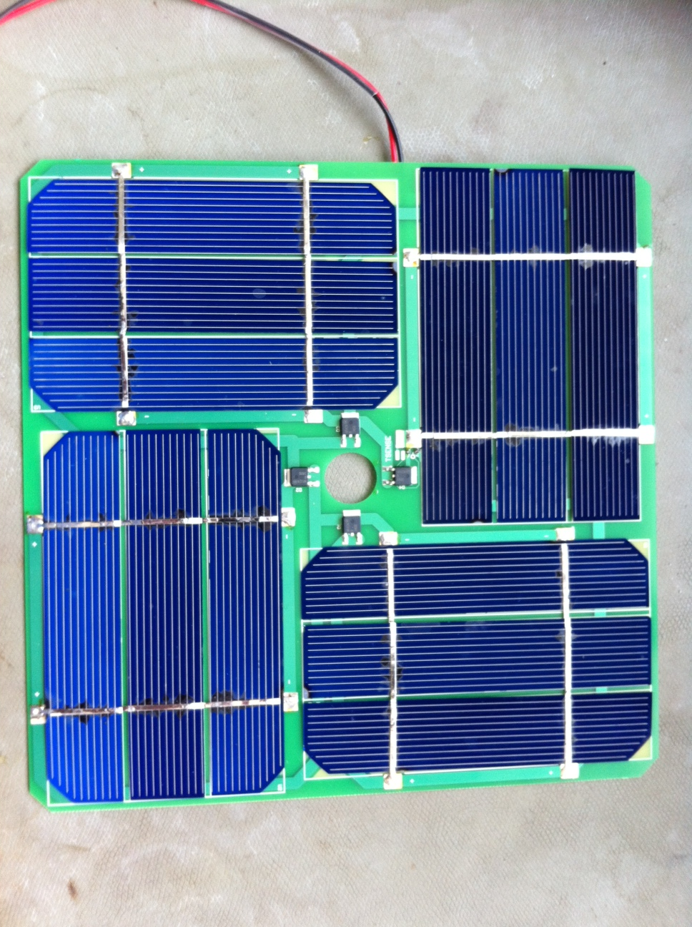

Figure 5.2.1 – Prototype of silicon solar panel

## Assembly and Mounting

To assemble each solar panel, solar cells are first connected in groups of 3 cells. Tabbing wire is soldered to the cells in order to connect them in series. The interconnected cells are then glued to the PCB using a thermally conductive epoxy, and the end connections of the groups of 3 are soldered to pads on the PCB.

Previous designs have involved the use of Fibreglass (FR4) PCB glued onto an aluminium panel (as can be seen in Figure 5.3.1). Because of difficulties in mounting the FR4 PCB to the Aluminium panel (further discussed in the next section), the decision has been to replace the aluminium panels and FR4 PCB with an aluminium backed PCB. This will both simplify the assembly of the solar array and allow the solar cells to be properly thermally coupled to the structure.

Difficulty has been encountered in assembling prototypes of the solar panels, as cells are very fragile. There has also been difficulty soldering the Tabbing wire to the cells, particularly in applying the correct amount of flux. This process needs to be improved before assemblies involving more expensive cells can be constructed.

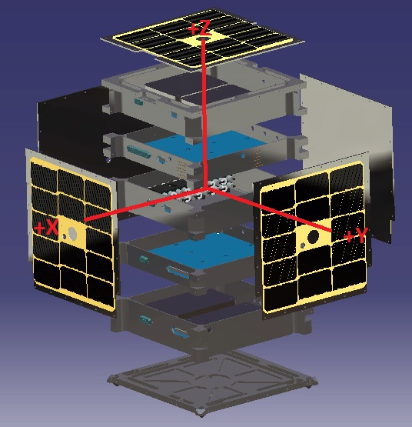

Figure 5.3.1 – Exploded view of satellite structure including solar array

# Future Work

## Batteries

* A suitable method of mounting the batteries to Tray 2 needs to be designed.

## Solar Array

* Design and construction of Aluminium backed PCB and panel.
* Cut high-quality monocrystalline silicon cells need to be sourced.
* Need for encapsulation of solar cells needs to be assessed. If needed, the method for encapsulation of cells needs to be decided on and tested.
* Perfect the assembly process of the solar panels.

1. Source: www.timeanddate.com/worldclock/astronomy.html?n=929&month=3&year=2012&obj=sun&afl=-11&day=1